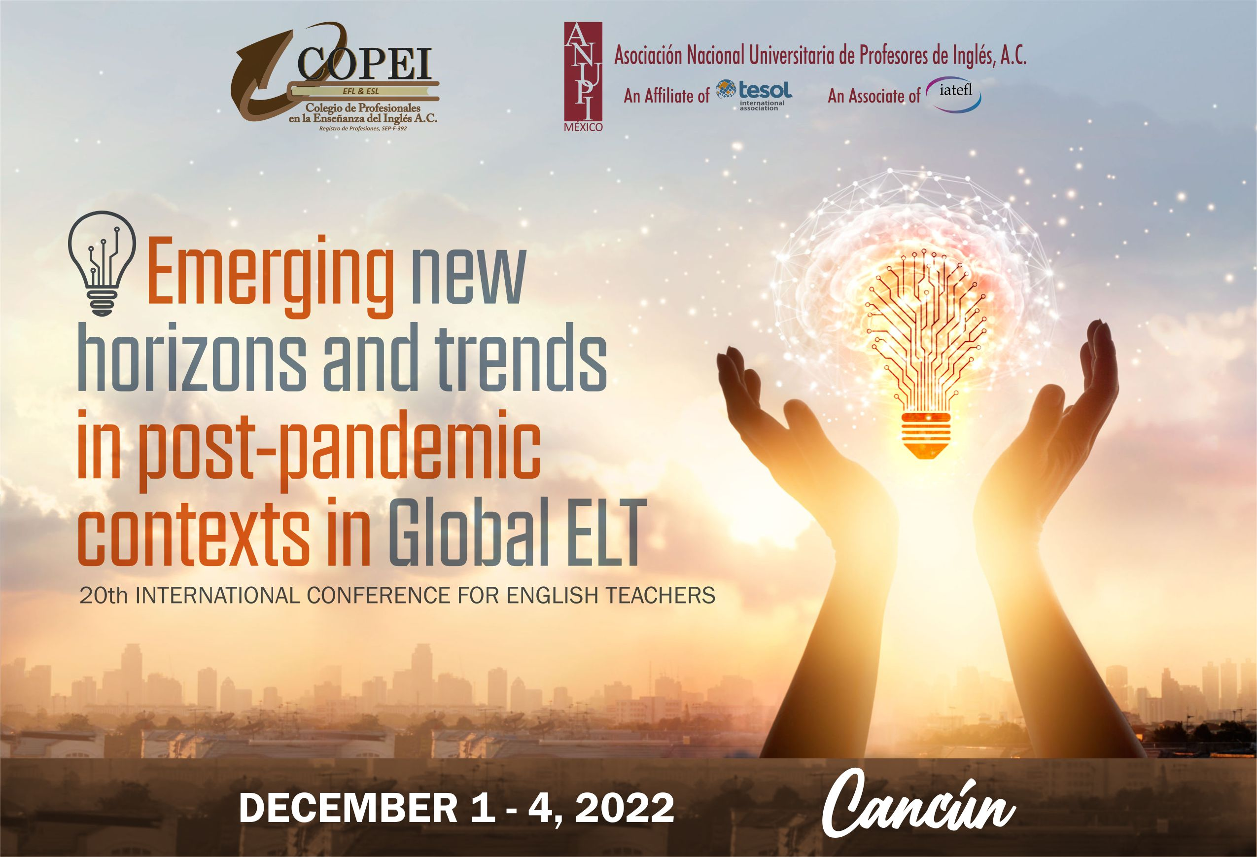

COPEI & ANUPI´S 2022 INTERNATIONAL CONFERENCE
"Emerging New Horizons and Trends in Post-pandemic Contexts in Global ELT"

December 1st – 4th, 2022
Cancun, Mexico.​
​
We are pleased to invite all interested English language teachers in Mexico and abroad to join us this year to celebrate our 20th International Conference.
​
The quality and high standards of our annual international conference has been recognized by the attendance and participation of public and private institutions from higher education in Mexico and abroad.

Important dates for Speakers:

Deadline for submission of proposals May 31st

Notification of accepted proposals June 15th

Registration deadline for presenters August 31st

CALL FOR PARTICIPATION 2022
"Emerging New Horizons and Trends in Post-pandemic Contexts in Global ELT"

Deadline May 31st, 2022
Presenter´s Guidelines for completing the Speaker Proposal Form
​To ensure that your proposal qualifies for selection, please read the guidelines below. Your proposal will not be considered unless it meets the guidelines.
​1. Details of Presenters:
Please write your full name and work affiliation clearly. This information will be printed in the program.
​2. Title of presentation
The maximum number of words in the title is 12.
​3. Type and Length of Presentation
a) Paper
A paper describes what you are doing, or have done, in relation to theory and practice. Its content must be of relevance and use to participants who work outside your your local context. Papers are 20 minutes long. Try to use visual aids during the session.
b) Demonstration
A demonstration is an academic presentation in which most of the time is used for showing, rather than telling, a technique for teaching or testing. Demonstrations are 20 minutes long. Try to use visual aids during the session.
c) Workshop
A workshop includes active participation through experiencing and discussing tasks provided by the presenter. Workshops are 50 minutes long.
We do our best to program a workshop in a room with moveable furniture but cannot guarantee this.
​
4. The abstract
The abstract will appear in the Conference Program, it should therefore accurately reflect the content of your presentation. No abstract may contain an offer of a free book or other materials. The abstract must be 50 to 60 words in length. An abstract which is below 50 words or above 60 words will not be considered.
5. The summary
All proposers are required to submit a 250-word summary. The summary will be read by the Academic Conference Committee. The summaries do not appear in the program.

6. “Cardinal Rules”
*Do not run over your allocated time
*Power point font size – HUGE please. Minimum 28pt
*On your first slide, please include the Title of your presentation, Name of Presenter(s), affiliation (if any) and your email address.
A kind reminder, something in your session must be NEW, PRACTICAL, INTERESTING, CHALLENGING, and STIMULATING.
​
The Academic Conference Committee will review and select those presentations which…
- have a direct relationship to the conference and are relevant to the audience.
- have a clear and precise organization.
- guarantee the Committee that the speaker knows the subject.
- are complete, edited and free of typographical mistakes.
- are not used to promote or sell the products or services of the speaker or others.
Presenters are encouraged to include and involve their audience, presenting in such a way as to stimulate the interest of the conference participants. It is strongly discouraged the reading aloud of written papers.

Before submitting your proposal, please read the notes below:
- Speakers may not submit or appear on more than two proposals, either as lead or co-presenters.
- The Conference Committee cannot guarantee a minimum or maximum number of participants in any presentation.
- Presenters and co-presenters must pay the conference fee and submit proof of payment before August 31st, 2022. After this day, if proof of payment is not received, your session may be cancelled. The registration fee is nonrefundable.
- All presenters should wear formal and casual attire during their presentations. The purpose of the dress code is to uphold the professional image of the conference.
- Presenters are encouraged to include and involve their audience, presenting in such a way as to stimulate the interest of the conference participants. It is strongly discouraged the reading aloud of written papers.

To submit your proposal, click below

https://forms.gle/HpyNXdaoVQA9L6ew6

Registration fees
}

Mexican Participants
Before May 30th | June 1st- September 30th | October 1st – November 15th
Members $1500 MXN | Members $1900 MXN | Members $2200 MXN
Non-members $2200 MXN | Non-members $2700 MXN | Non-members $3000 MXN

International Participants
Before May 30th | June 1st- September 30th | October 1st – November 15th
Members $75 USD | Members $95 USD | Members $110 USD
Non-members $110 USD | Non-members $135 USD | Non-members $150 USD

Registration fees include: Attendance to all sessions, digital program, conference certificate and one-year membership to ANUPI.

PAYMENT information for Mexican participants:
​
·Bank: Santander
·Bank deposit Name: Colegio de Profesionales en la Enseñanza del Ingles, COPEI A.C.
·Account number: 92-00148810- 9
·Transfer: 014650 9200148 81090

​
International Participants: Credit and Debit Card payment through PayPal (PayPal includes 5% commission payment)

Members: PayPal.Me

Nonmembers: PayPal.Me

When making your deposit or transfer please send your voucher to our email asociacion@anupi.org.mx and fill in your registration to the congress.

Conference registration, click below

https://forms.gle/CqXCcbTcJcegwsND8

